Golas, Ekal

UNIVERSITY OF TEXAS AT DALLAS | 800 W CaMPBELL RD RICHARDSON TX 75080

MINI PROJECT 6

Statistical methods for data science



Table of Contents

Answers 2

R Code 6

# Answers

The answers to the questions stated in (Choudhary, 2015) are as follows:-

1. **Consider the prostate cancer dataset from Mini Project 5. Choose one more quantitative or qualitative variable to add to the final model built in that project and justify by our choice. Fit a linear model using the two variables and carry out regression diagnostics. The analysis should include an assessment of the degree to which the key regression assumptions are satisfied. If an assumption is not met, attempt to remedy the situation. Comment on the fit of the final model using appropriate tests and statistics.**

Cancer volume is chosen as one more variable to be added to the final model. The model now is:-

Call:

lm(formula = log(cancer.data$psa) ~ log(cancer.data$weight) + (cancer.data$cancervol), data = cancer.data)

Residuals:

Min 1Q Median 3Q Max

-1.84693 -0.51186 0.06564 0.49863 1.95827

Coefficients: Estimate Std. Error t value Pr(>|t|)

(Intercept) -0.29038 0.62882 -0.462 0.64531

log(cancer.data$weight) 0.58544 0.17279 3.388 0.00103 **

cancer.data$cancervol 0.09010 0.01089 8.270 8.63e-13 ***

---

Signif. codes: 0 ‘***’ 0.001 ‘**’ 0.01 ‘*’ 0.05 ‘.’ 0.1 ‘ ’ 1

Residual standard error: 0.8297 on 94 degrees of freedom

Multiple R-squared: 0.4936, Adjusted R-squared: 0.4828

F-statistic: 45.81 on 2 and 94 DF, p-value: 1.293e-14

The plots for the above model are as follows:-

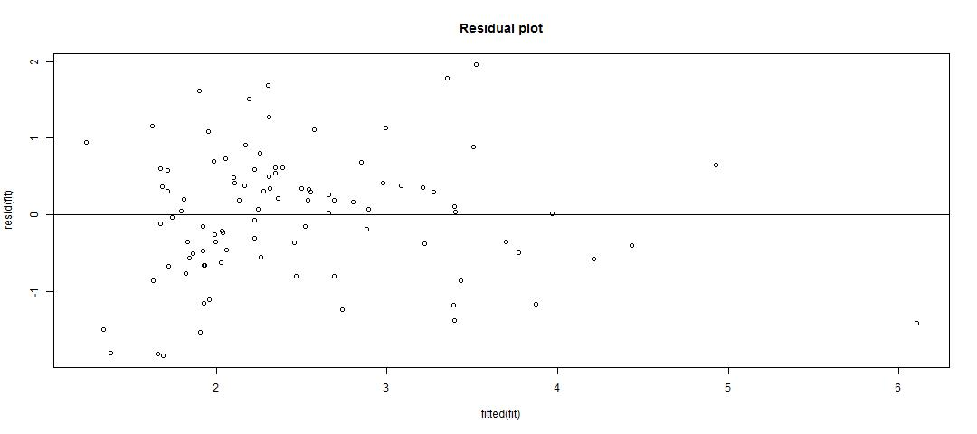

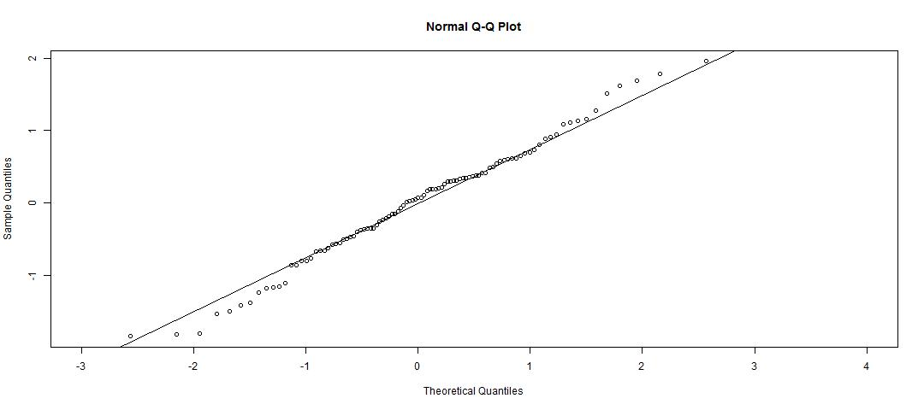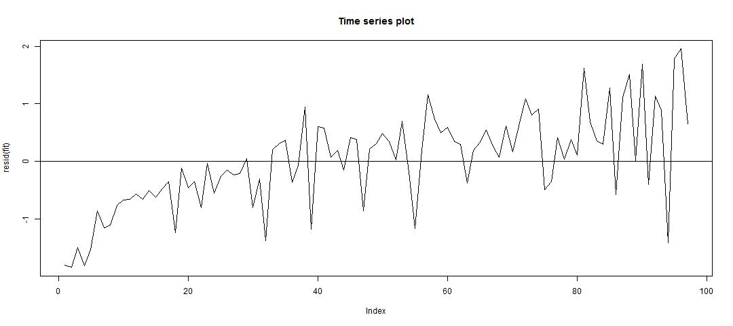

From the above plots we can see that the key regression assumptions are slightly violated. Hence log transform of the new variable is applied and the final model is computed as:-

Call:

lm(formula = log(cancer.data$psa) ~ log(cancer.data$weight) + log(cancer.data$cancervol), data = cancer.data)

Residuals:

Min 1Q Median 3Q Max

-1.6235 -0.5043 -0.0219 0.5202 1.9060

Coefficients: Estimate Std. Error t value Pr(>|t|)

(Intercept) -0.30097 0.56903 -0.529 0.5981

log(cancer.data$weight) 0.51096 0.15723 3.250 0.0016 **

log(cancer.data$cancervol) 0.67662 0.06628 10.208 <2e-16 ***

---

Signif. codes: 0 ‘***’ 0.001 ‘**’ 0.01 ‘*’ 0.05 ‘.’ 0.1 ‘ ’ 1

Residual standard error: 0.751 on 94 degrees of freedom

Multiple R-squared: 0.5851, Adjusted R-squared: 0.5763

F-statistic: 66.28 on 2 and 94 DF, p-value: < 2.2e-16

The plots for the final model are as follows:-

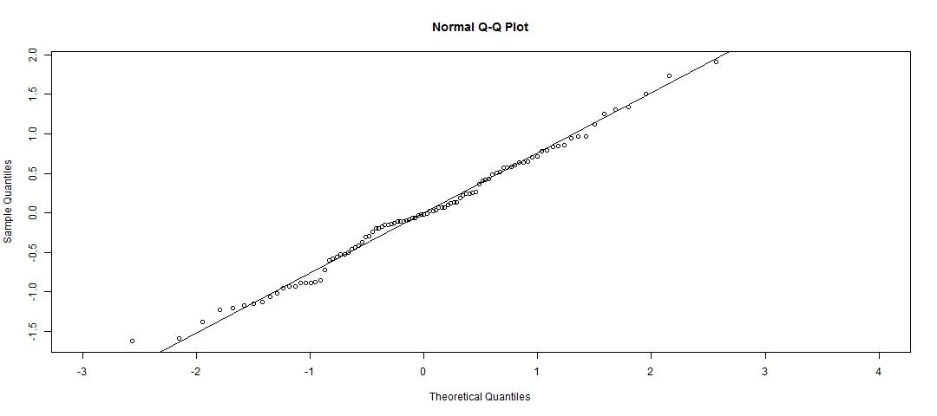

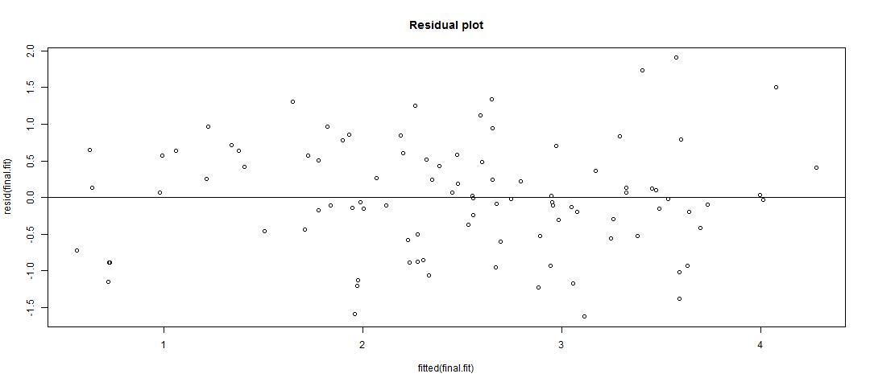

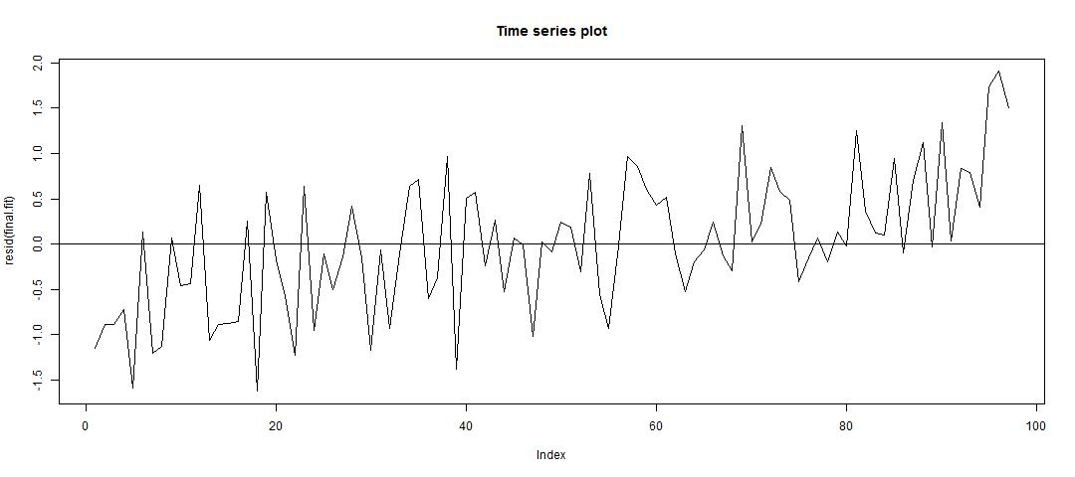

From the above plots, we can see that the key regression assumptions are more closely satisfied than the initial model.

1. **Use the final model to predict the PSA level for a patient whose predictor variables are at the sample medians of the variables.**

The median of the Weight variable is 37.338 and the median for Cancer Volume variable is 4.2631.

The PSA level for the patient at the median value of Cancer Volume is predicated as 6.822878. The PSA level for the patient at the median value of Weight is predicated as 12.716789

# R Code

# Read the data

cancer.data = read.table("prostate_cancer.csv", sep = ",", header = TRUE)

# Fit the model with two variables

fit = lm(log(cancer.data$psa) ~ log(cancer.data$weight) + (cancer.data$cancervol), cancer.data)

summary(fit)

# Residual plot

jpeg("Residual plot.jpg", width = 1080, height = 480)

plot(fitted(fit), resid(fit), main = "Residual plot")

abline(h=0)

dev.off()

# QQ plot

jpeg("QQ Plot.jpg", width = 1080, height = 480)

qqnorm(resid(fit), xlim = c(-3, 4))

qqline(resid(fit))

dev.off()

# Time series plot of residuals

jpeg("Time series plot.jpg", width = 1080, height = 480)

plot(resid(fit), type="l", main = "Time series plot")

abline(h=0)

dev.off

# Log transform and fit the model with two variables

final.fit = lm(log(cancer.data$psa) ~ log(cancer.data$weight) + log(cancer.data$cancervol), cancer.data)

summary(final.fit)

# Residual plot

jpeg("Final - Residual plot.jpg", width = 1080, height = 480)

plot(fitted(final.fit), resid(final.fit), main = "Residual plot")

abline(h=0)

dev.off()

# QQ plot

jpeg("Final - QQ Plot.jpg", width = 1080, height = 480)

qqnorm(resid(final.fit), xlim = c(-3, 4))

qqline(resid(final.fit))

dev.off()

# Time series plot of residuals

jpeg("Final - Time series plot.jpg", width = 1080, height = 480)

plot(resid(final.fit), type="l", main = "Time series plot")

abline(h=0)

dev.off()

# Predict for median

weight.median = median(cancer.data$weight)

cancervol.median = median(cancer.data$cancervol)

index = cancer.data[which(cancer.data$weight == weight.median | cancer.data$cancervol == cancervol.median), ]

new.data = data.frame(x = c(weight.median, cancervol.median))

prediction = predict(fit, newdata = new.data)

exp(prediction[index$subject])